 | School: Duc Chinh Primary School  Class: 4  Name: |  |  |  |  |  |  |  | THE FIRST SEMESTER TEST  SUBJECT: ENGLISH - GRADE 4  SCHOOL YEAR: 2024 - 2025  Time: 35 mins
Mark |  | Listening |  |  |  | Reading and Writing |  |  |  |  |  | Speaking | Total
 |  | Q1 | Q2 | Q3 | Q4 | Q5 | Q6 | Q7 |  | Q8 | Q9
Comment:

PART I. LISTENING (15’)
Question 1:Listen and tick. There is one example.(1pt)

0. |  |  | 
  A.
  B.
  C.
1. |  |  | 
  A.
  B.
  C.
2. |  | 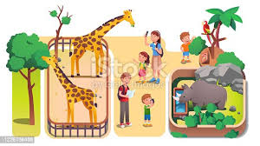 | 
  A.
  B.
  C.
3. |  |  | 
  A.
  B.
  C.
4. |  |  | 
  A.
  B.
  C.

Question 2: Listen and number. There is one example.(1pt)
A   | B   | C   | D  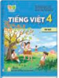 | E  
0

Question 3: Listen and draw line. There is one example. (1pt)

 | A   | B   | C   | D   | E  
4
3
2
1
0

Question 4: Listen and complete. There is one example.(1pt)
0. I study at school.
1. I’m from ………………………
2. I want to be a ………………… teacher.
3. He likes ……………………..
4. When’s your birthday? – It’s in ………..……………
PART II. READING AND WRITING (20’)
Question 5. Look at the pictures and the letters. Reorder the words. (1pt)
 |  |  |  | 
(0). niraBit  Britain | 1.nuringn  ____________ | 2. scphi  __________ | 3. retapin  __________ | 4. saninomut  ___________
Question 6: Read and match the words with pictures. There is one example. (1pt)
0. buildings | A 
1. IT | B 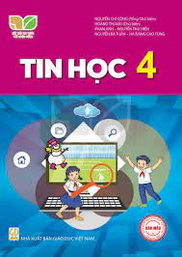
2. English teacher | C 
3. Australia | D 
4. listen to music | E 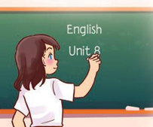
Question 7. Read and choose a, b or c to complete. There is one example. (1pt)
There are four people in my (0) family. My father (1)……………….…… swim very well. My mother can cook but she can’t (2)……………….…the piano. My brother can play football and play (3) ………….. guitar but he can’t dance. I like music, I can sing (4)………… dance but I can’t cook.
0.a. friend b.teacher c.family
1. a. do b. can c. is
2. a. play b. does c. do
3. a. go b. the c. a
4. a. on b. to c. and
Question 8. Read and tick (√) True or False. There is an example .(1pt)
Hello, My name is Linh. I have four friends: Mary, Lucy, Ben, Minh. Mary can play the piano, but she can’t play the guitar. Lucy can cook, but she can’t ride a bike. Ben can ride a horse, but he can’t draw. Minh can play football, but he can’t roller skate. I can cook, but I can’t swim. We all can sing and dance.
 |  | TRUE | FALSE
0. | Linh has three friends. |  | √
1 | Linh can swim but Lan can’t cook.
1. | Mary can play the piano, but she can’t play the guitar.
2. | Ben can ride a horse and draw.
3 | Linh, Mary, Lucy, Ben and Minh can sing and dance.
Question 9: Reorder the words. There’s one example (1pt)

(0). is/ What/ time/ it /?/

→ What time is it?

1. ten/ I/ at/ lunch/ have/ fifteen/./
……………………………………………………………………………..

2. school/ has/ My/ garden/ a/./
…………………………………………...………………………………..
…………………………………………………………………………………..

3. subject/your / What’s /favourite/ ? /
……………………………………………………………………………..

4. do/on/ I/ Sundays/ Saturdays/ and/ housework/./
…………………………………………...………………..………………..
…………………………………………………………………………………..

PART III: SPEAKING (1pt)
1. Get to know each other (Interview) | 2. Look, point and say
3. Let’s talk
-------------The End-------------
Giáo viên coi …………..…..…… Giáo viên chấm…………………………

