 | School: Duc Chinh Primary School  Class: 5  Name: |  |  |  |  |  |  |  | THE FIRST SEMESTER TEST  SUBJECT: ENGLISH - GRADE 5  SCHOOL YEAR: 2025 - 2026  Time: 35 mins
Mark |  | Listening |  |  |  | Reading and Writing |  |  |  |  |  | Speaking | Total
 |  | Q1 | Q2 | Q3 | Q4 | Q5 | Q6 | Q7 |  | Q8 | Q9
Comment:

PART I. LISTENING (15’)
Question 1: Listen and circle the correct picture. There is one example. (1pt)
- What did Mary and her friends do at Ba Na Hills last weekend?
a.  b. 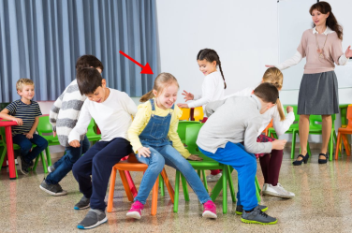
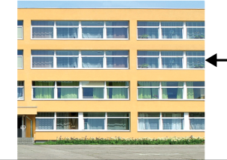


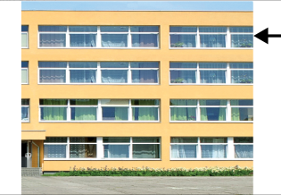

- a. b. 2. a. b.

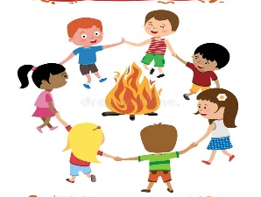

3. a b. 4. a. b.
Question 2. Listen and choose the correct answers. There is one example. (1pt)
- Could you tell me the way to the art room please?
______________. It's on your left.
A. Go upstairs B. Go downstairs C. Go along the corridor
1. Bill had a school trip in Yen So Park ______.
A. last Friday B. last Sunday C. last Saturday
2. What did Bill and his classmates do in the morning?
A. played the guitar B. walked around the lake C. had a party
3. Who played the guitar at the party?
A. Mr. Long B. Bill C. Bill’s class
4. What time did the school trip end?
- at noon B. 3 p.m C. 4 p.m
Question 3: Listen and tick or cross. There is one example. (1)







- 1. 2. 3. 4.
Question 4. Listen and complete. There is one example. (1pt)
0. Where's your classroom?
It's on the second floor of A1 building.
1. Could you tell me the way to the library, Hoa?
Go upstairs and ____________________.
2. Do you live in this building?
No. I don't. I live in ___________________ near here.
3. What school activity does Lan like?
She likes playing _____________________.
4. Did your class go to Da Nang last year?
Yes. We did. We visited _________________.
PART II. READING AND WRITING (20’)
Question 5: Read and complete. There is one example. (1pt)
in front of
theatre
first
playing
left

- The music room is on the first floor. 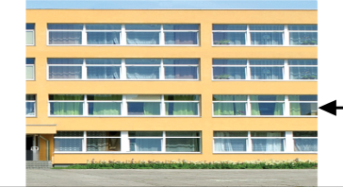
- Go straight the corridor and turn _______________. 
2.His favourite school activity is __________________ games. 
3.They listened to music at the _____________ yesterday evening. 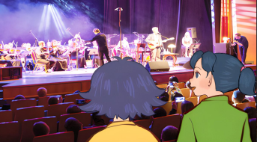
4.The pens are__________________ the clock. 

Question 6: Read and circle. There is one example. (1pt)
- What school activity does she like?
- I like reading books. C. She likes doing projects with her friends.
- She’d like to be a reporter.
- Whose pencil sharpener is this?
- It’s Mai’s. B. It’s beside the board. C. It’s beautiful.
- Could you tell me the way to the park, please?
- It’s on the first floor. B. Go straight and turn left. C. It’s interesting.
- Were you at the aquarium last weekend?
A.Yes, we were. We had a great time there. C. Yes, we did. We like it very much.
B. Yes, we are. It’s really interesting.
4. Did they go to Ba Na Hills last summer holiday?
A. No, they weren’t. They were at home. C. Yes, they did. They had a lot of fun.
B. No, they don’t. They wanted to go to Suoi Tien Theme Park.
Question 7 : Look, read and match. There is one example. (1pt)
A | B | Answer
- Where’s the computer room? | a. I like going for a walk. | 0. d
- What do you like doing in your free time? | b. I always play the piano. | 1. __
- What would you like to be in the future? | c. Because it’s fun. | 2. __
- What do you do at the weekend? | d. It’s on the third floor. | 3. __
- Why does he like playing football? | e. I’d like to be a firefighter. | 4. __
Question 8: Read the passage and tick True or False. There is one example. (1pt)
I’m Mina. There are five people in my family: my father, my mother, my sister, my brother and me. My sister likes playing games because she thinks it's interesting. My brother doesn't like solving maths problems or reading books. He thinks they are boring. He likes doing projects. I enjoy doing projects because they are fun and creative. Playing games is also my favorite activity because it is exciting. At school, I like learning with my friends. School is a great place to explore and have fun.
T F
√
- There are four people in her family.
- Her sister likes reading fairy tales.
- Her brother likes solving maths problems.
- Her brother likes doing projects.
- Mina likes learning with her friends.
Question 9: Reorder the words. There’s one example (1pt)
- did / Where / go / weekend /you /?/ last
Where did you go last weekend?
1. free / do/ What / doing / in / time/ your / you / like/?/
……………………………………………………………………………..

- a/ I’d/ to be/ firefighter/ the/ like/ in/ future/./
…………………………………………...………………………………..
…………………………………………………………………………………..

- does/ Why/ like/ solving/ maths/ she/ problems/?/
……………………………………………………………………………..

- danced/ We/ the/ campfire/ around/ last weekend/./
…………………………………………...………………..………………..
…………………………………………………………………………………..

PART III: SPEAKING (1pt)
1. Get to know each other (Interview) | 2. Look, point and say
3. Let’s talk
-------------The End--------------

Giáo viên coi …………..…..…… Giáo viên chấm…………………………

