School: Duc Chinh Primary School  Class: 3  Name: |  |  |  |  |  |  |  | THE FIRST SEMESTER TEST  SUBJECT: ENGLISH - GRADE 3  SCHOOL YEAR: 2025 - 2026  Time: 35 mins
Mark | Listening |  |  |  |  | Reading and Writing |  |  |  |  |  | Speaking | Total
 | Q1 | Q2 |  | Q3 | Q4 | Q5 | Q6 |  | Q7 | Q8 | Q9
Comment:

PART I. LISTENING (15’)

Question 1. Listen and tick ( ) the box. There is one example (1pt)

0. A.  | B. 
1. A. 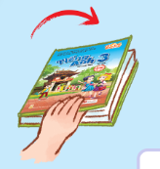 | B. 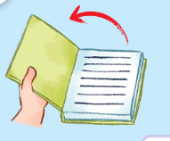
2. A. 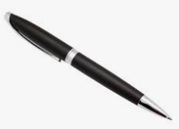 | B. 
3. A.  | B. 
4. A.  | B. 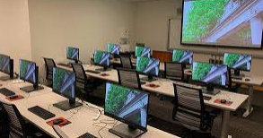

Question 2: Listen and match. There is one example. (1 pt)

A. 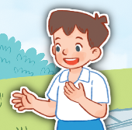 | B.  | C.  | D.  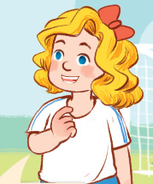 | E. 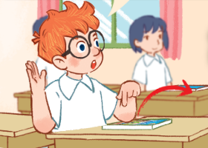

4
3
2
1
0

Question 3: Listen and number. There is one example. (1 pt)
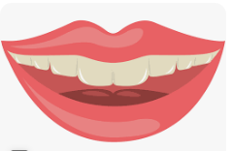  0 | A. |   B. |   C. |   D.
Question 4: Listen and write. There is one example. (1 pt)

0. What’s your name? - My name’s Lam.

1. A: What’s your hobby?

B: I like ……………………………… .

2. May I ………………………………… ?

3. The pencils are ………………………. .

4. A: What do you do at break time?

B: I play……………………………… .
PART II. READING AND WRITING (20’)
Question 5: Look, read and circle the correct answer. There is one example. (1 pt)
0. A: How old are you?  B: I’m……....…. years old.  a  . seven b. eight c. ten | 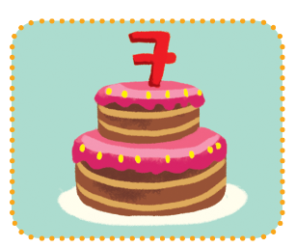
1. A: May I …………………?  B: Yes, you can.  a. sit down b. open the book c. go out | 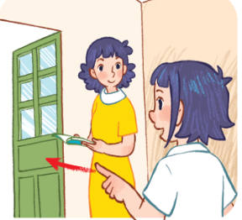
2. A: Do you have a…………………?  B: Yes, I do.  a. ruler b. notebook c. eraser | 
3. A: What do you do at break time?  B: I play………………  a. badminton b. table tennis c. football | 
4. A: Is this the ………………...?  B: Yes, it is.  a. music room b. gym c. computer room | 

Question 6: Read and match. There is one example (1pt)
A
B

0. May I come in? | 0 - d  1 ……  2……...  3……... | a. They’re blue.
- Do you have a ruler? | 0 - d  1 ……  2……...  3……... | b. It’s an eye.
2. What colour are they? | 0 - d  1 ……  2……...  3……... | c. I play chess.
3. What do you do at break time? | 0 - d  1 ……  2……...  3……... | d. Yes, you can.
4. What’s this? | 4……... | e. Yes, I do.

Question 7: Look and fill in the gaps. There is one example (1pt)
0. Touch your hair! | 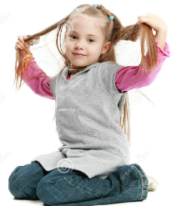
1. ……………… is Ben. | 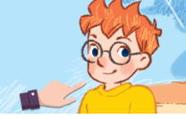
2. At break time, I play……………………… . | 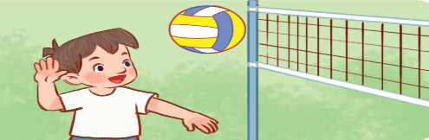
3. A: What’s your hobby?  B: I like…………………………… . | 
4. That is the ………………………… . | 
Question 8: Look at the picture and complete the sentences. There is one example. (1 pt)
Example: 0. This is Lucy. 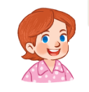
1. That’s our ………..………….! 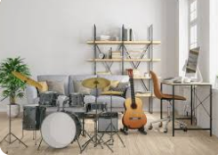
2. I have a ……………..………. 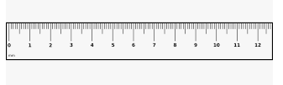
3. Touch your ………..………….! 
4. I’m ……………..… years old. 

Question 9: Reorder the words to make a correct sentence. There is one example. (1pt)
0. Mai / My / is / name / . /
=> My name is Mai.
1. classroom / that / your / Is / ? /
=> ………………………………….……………………………
2. cooking / like / and / singing / I / . /
=> ………………….……………..…………………………….
3. chess / at / I / time / play / break / . /
=> …………………….…………..……………………………..
4. and / My / school bag / black / is / white / . /
=> …………………….…………..……………………………...
PART III: SPEAKING ( 1pt )
1. Get to know each other (Interview) | 3. Point, ask and answer
2. Listen and repeat
-------------The End--------------
Giáo viên coi: …………..…..…… Giáo viên chấm: …………………………

