School: Duc Chinh Primary School  Class: 2  Name: |  |  |  |  |  | THE FIRST SEMESTER TEST  SUBJECT: ENGLISH - GRADE 2  SCHOOL YEAR: 2025 - 2026  Time: 35 mins
Mark | Listening |  |  | Reading and Writing |  |  |  | Speaking | Total
 | Q1 |  | Q2 | Q3 | Q4 |  | Q5 | Q6
Comment:

Part I: Listening: 5 points
Question 1: Listen and tick. There’s one example. (2.5 points)
1. |  |   √ | 2. |  | 
 | a. | b.
3. |  |  | 4. |  | 
5. |  |  | 6. |  | 

Question 2: Listen and number. There is one example. (2.5 points)

  a. |   1  b. | c.
d. |   e. | f.

Part II: Reading and writing: 4 points
Question 3: Look and read. Put a tick (√) or a cross (x) in the box. There are two examples.
(2 points)
- They are my shoes. |  | √
- This is a blue dress. |  | X
- A: What color is the zebra?  B: It’s white and black. | 
- There are eleven elephants. |   
- My backpack is big.
- This is my sister. | 

Question 4: Look, read and circle. There is one example. (1 point)
- This is my mum. / dad.

- It’s a / an lion. | 
- My mum is small/ big. | 
- My brother is young. / old. | 
- It is a zebra. / giraffe. | 

Question 5: Look at the pictures and the letters, write the words. There is one example.

(1 point)
  1. | 2. |   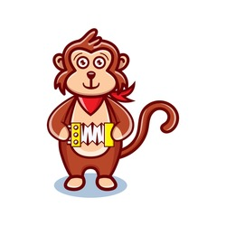  3. 4. 5.
g b i  b i g | s t e s i r  …………… | m k y e o n  …………… | i o n l a d d  …………. ……………
Part III: Speaking: 1 point
Question 6:
1. Listen and repeat 2. Look and say

Giáo viên coi: ………………………… Giáo viên chấm: ………………………

